2nd Annual School Safety Training Conference

February 20th – 23rd 2023
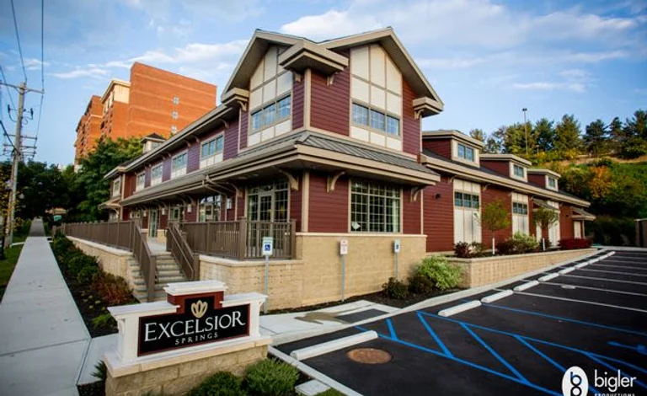
Excelsior Springs Event Center, 11 Excelsior Ave Saratoga Springs, NY 12866

Conference Schedule

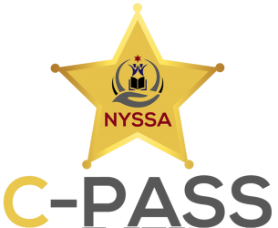

The Committee on Policing and Safeguarding Schools (C-PASS) understands that protecting students is an ever changing task and one of the upmost importance. The committee constantly strives to identify new issues and develop training to meet those needs faced not only by school resources officers but all those involved in the school community. Since the committee is not bound by a single state agency, or under any state mandate, C-PASS can be flexible and swift in tackling new school issues. We have been successful thus far in all of our endeavors by understanding the importance of collaboration, because in the end we are always BETTER TOGETHER.

C-PASS School Safety Training Conference Schedule

February 19th 2023
16:00 – 21:00 Registration Begins – Hotel Basement Lobby

February 20th 2023
07:00 – 08:00 Registration & Coffee & Refreshments
08:00 – 09:00 Opening Ceremonies – Jonathan Becker, Chief Crooks, Sheriff Zurlo, Sheriff Apple, Under Sheriff McNelis, NYSSA, Robert Holt and Sean Armstrong
09:00 – 12:00 Lockdown Drills Connecting Research and Best Practices– Dr. Jaclyn Schildkraut
12:00 – 13:00 Lunch
13:00 – 15:00 Arapahoe High Debrief – Deputy James Englert – Colorado
15:00 – 16:00 Bullying Sensitivity Training – SSS Vernon House NYPD
16:00 – 16:30 Daily Debrief

February 21st 2023
07:00 – 08:00 Coffee & Refreshments
08:00 – 10:00 Bullying and Crisis Prevention – Dr. Amanda Nickerson– University of Buffalo
10:00 – 12:00 CSTAG/Threat Assessment - Dr. Dewey Cornell – University of Virginia
12:00 – 13:00 Lunch
13:00 – 15:00 Threat Assessment – The National Threat Assessment Center – United State Secret Service
15:00 – 16:00 LGBTQIA+ Sensitivity Training – SSS Vernon House NYPD
16:00 – 16:30 Daily Debrief
18:30 – 22:30 Networking Dinner and Live Music – Excelsior Center

February 22nd 2023
07:00 – 0:800 Coffee and Refreshments
08:00 – 12:00 Standard Reunification Method Workshop – Dan Rector – I Love U Guys
12:00 – 13:00 Lunch
13:00 – 16:00 Post-Traumatic Stress Disorder, To protect and serve those that protect and serve – Sheriff Whitcomb
16:00 – 16:30 Daily Debrief

February 23rd 2022
07:00 – 0:800 Coffee and Refreshments
08:00 – 11:45 The lessons learned from the lives lost, The Uvalde Debrief – Tom Czyz - Armoured One
11:45 – 12:00 Closing and Farewell

